/usr/java/jdk1.8.0_201/jre

vi .bash_profile - set the above path

ECHO $JAVA_HOME

unzip Tc12.2.0_patch_7_lnx64.zip - base binaries
unzip Tc12.2.2_patch_7_lnx64.zip - patch binaries

./tem.sh

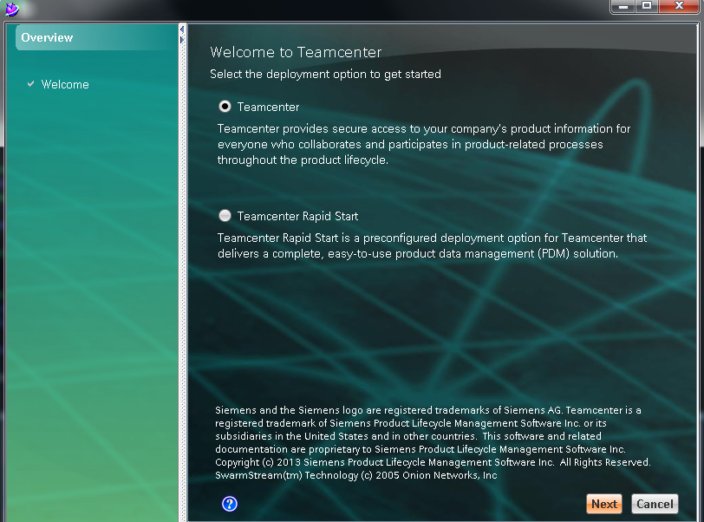

In original media – select 12.2 binaries
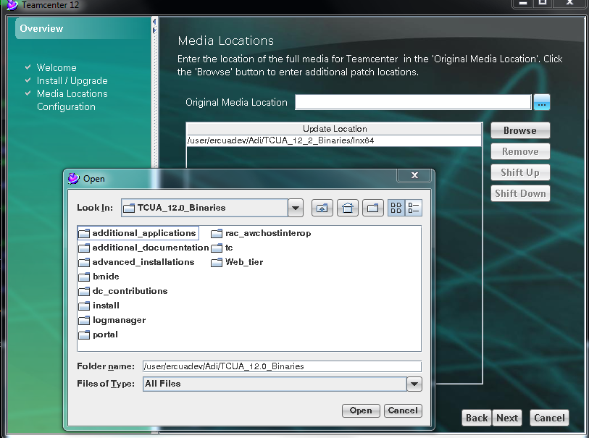

Click on next

Give ercuadev as id and desc
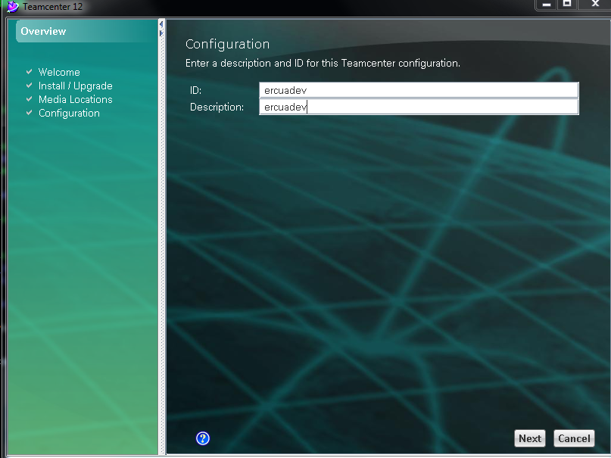

Select corporate and volume server-

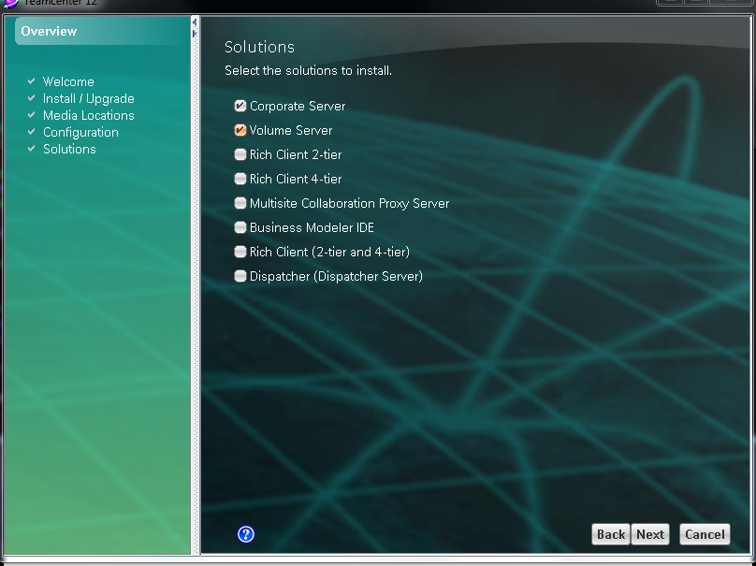

Temp foundation
Java ee ---for pool manager
Fms_server cache --- for fsc and sample files
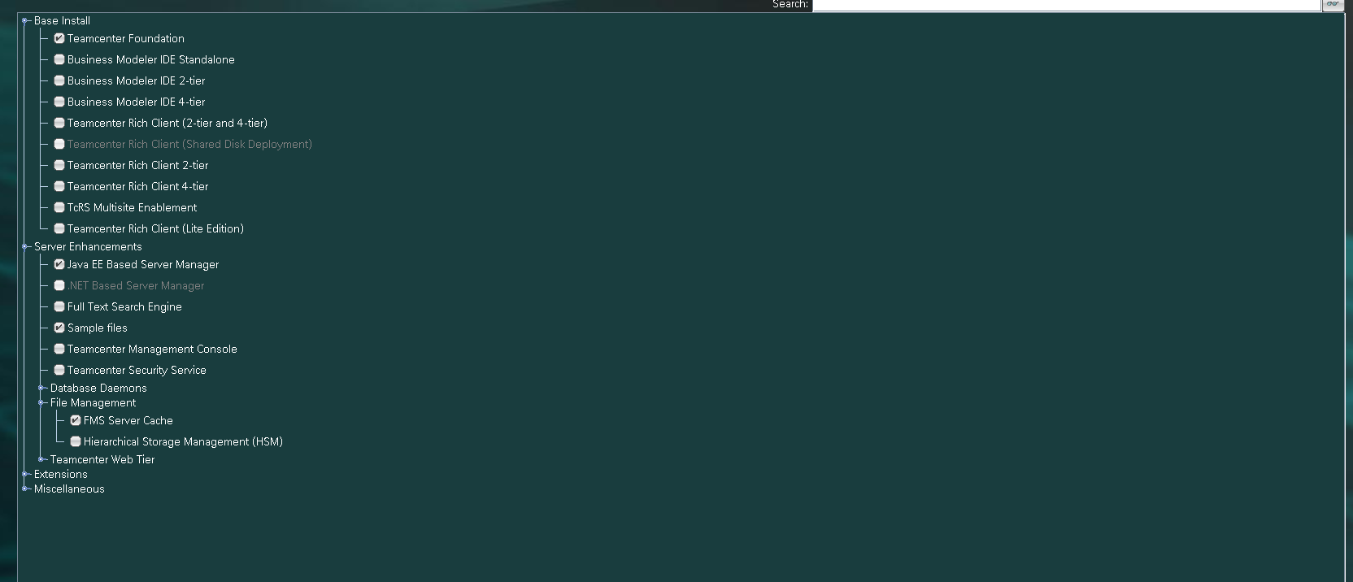

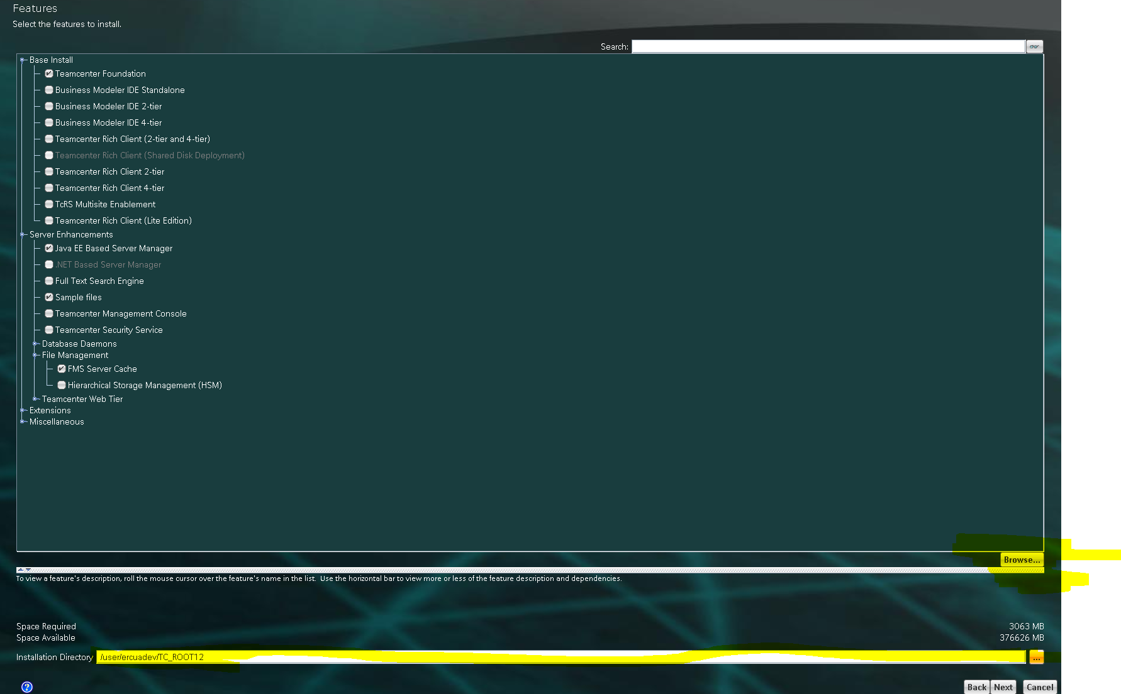

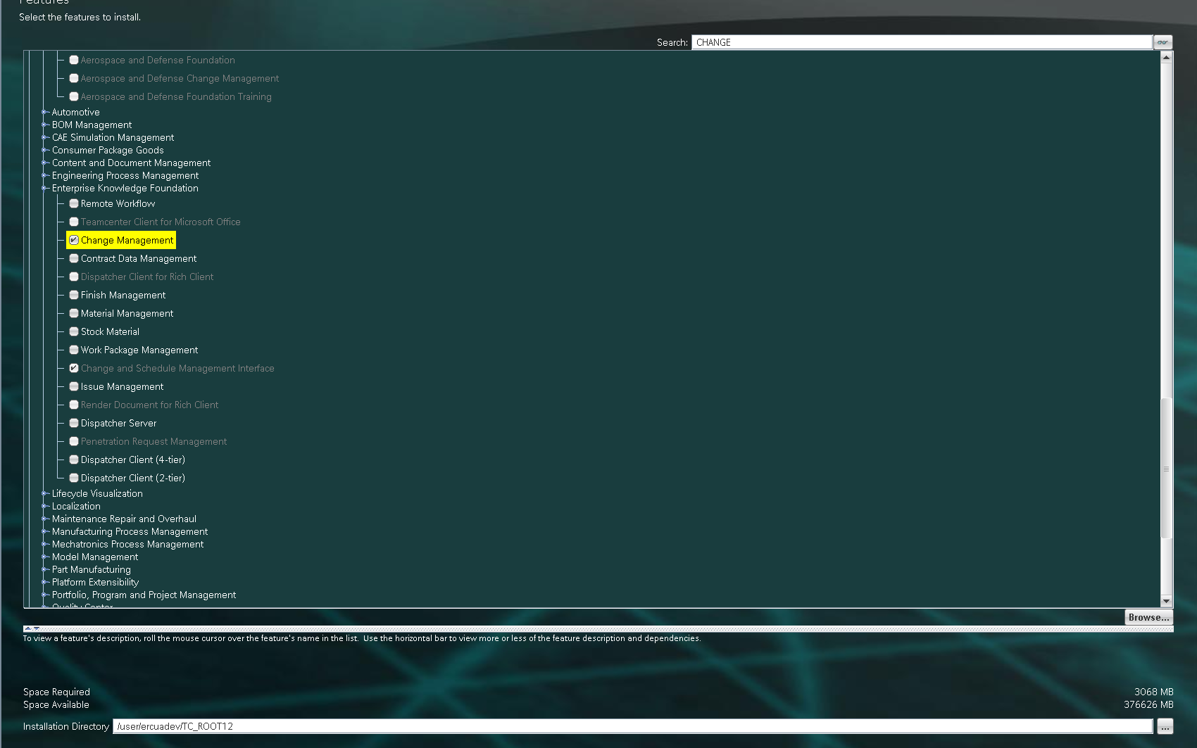

Check which server port is used –

mvlph1tu7 tcuaadev [~] $ netstart -anp | grep 4544
netstart: command not found
tmvlph1tu7 tcuaadev [~] $ netstat -anp | grep 4544
(Not all processes could be identified, non-owned process info
will not be shown, you would have to be root to see it all.)
tcp 0 0 0.0.0.0:4544 0.0.0.0:* LISTEN -
tcp 1 0 172.22.97.90:57228 172.22.97.90:4544 CLOSE_WAIT -
tmvlph1tu7 tcuaadev [~] $

tmvlph1tu7 tcuaadev [~] $ netstat -anp | grep 8544
(Not all processes could be identified, non-owned process info
will not be shown, you would have to be root to see it all.)
tmvlph1tu7 tcuaadev [~] $

8544 not found – hence using that

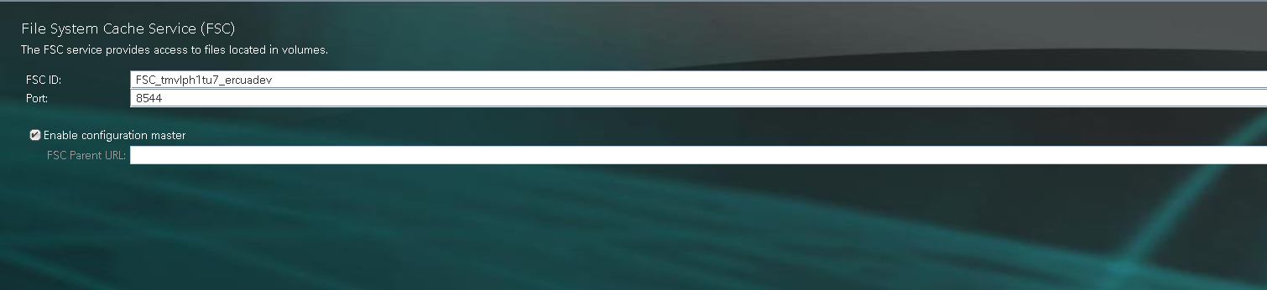

Syatem gives message that you have no write permission hence do the following
In cache – add _ercuadev in EXISTING fsc_id

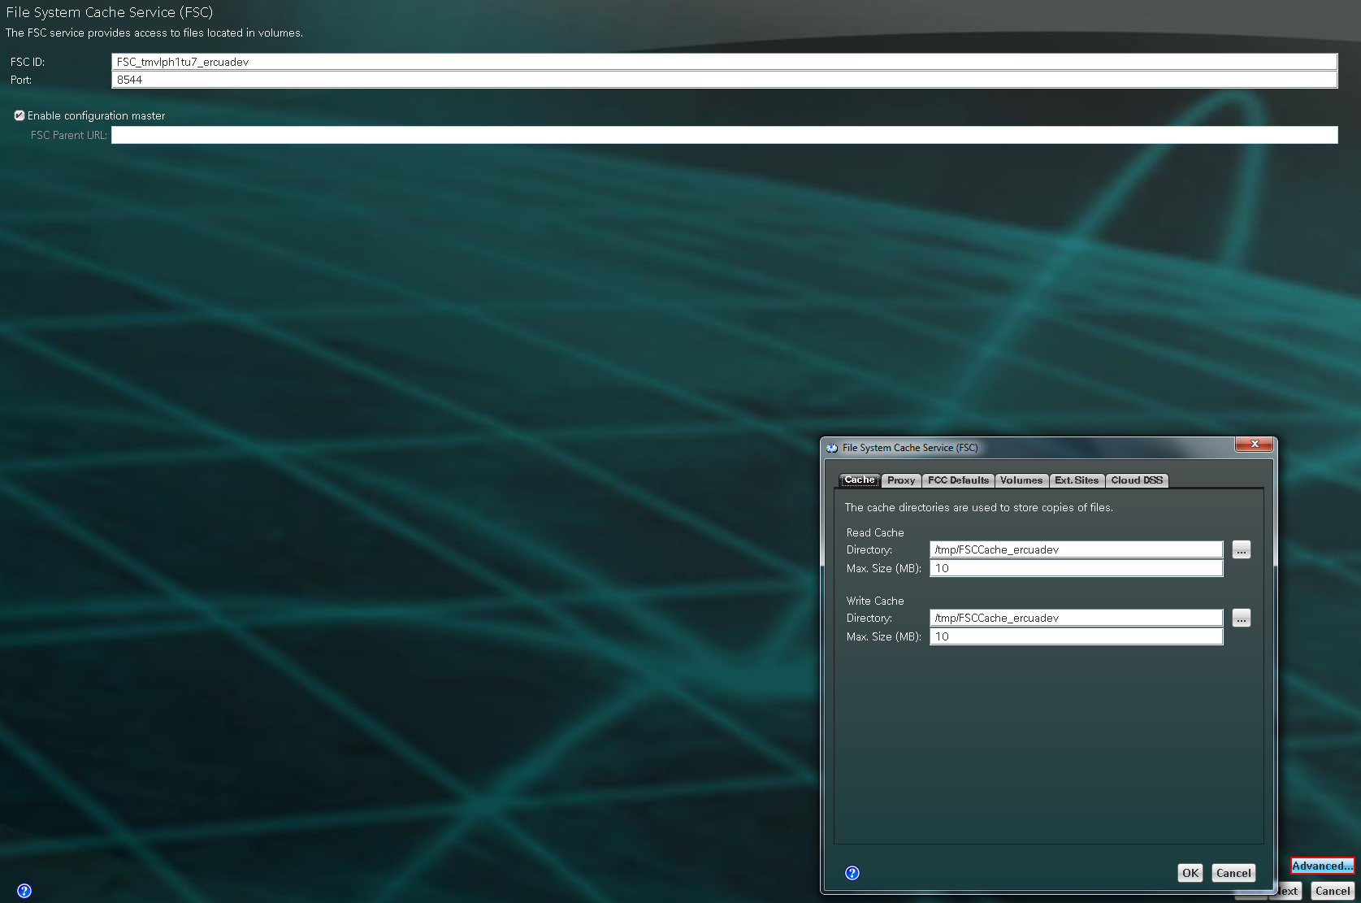

In fcc defaults – add _ercuadev after FCCCache in windows and unix cache directory.
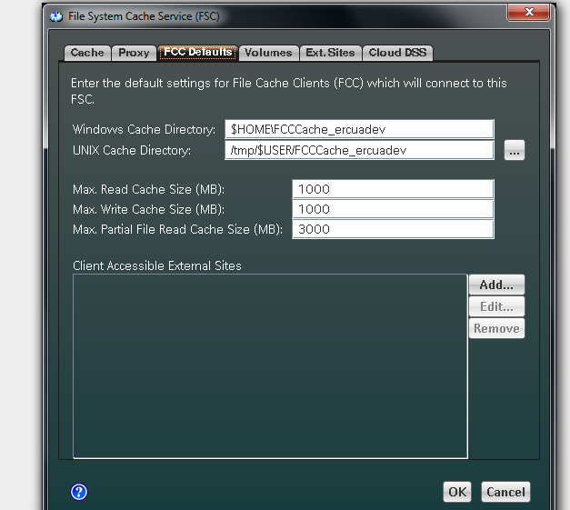

CLICK OK – then next

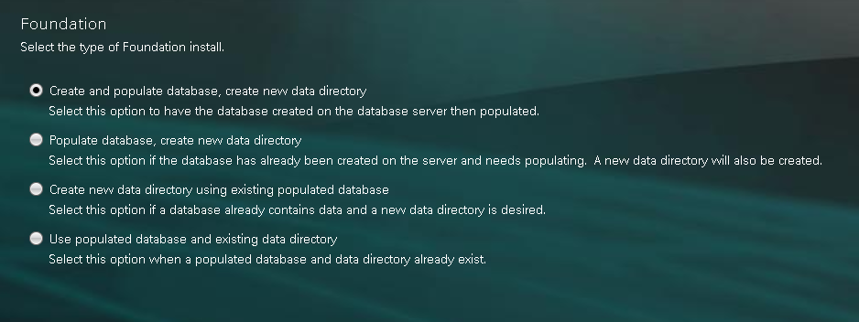

PASSWORD - oracle

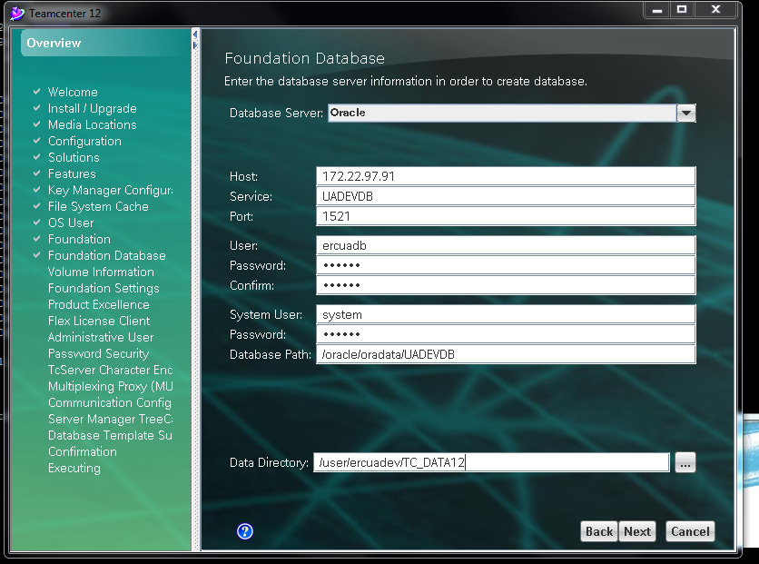

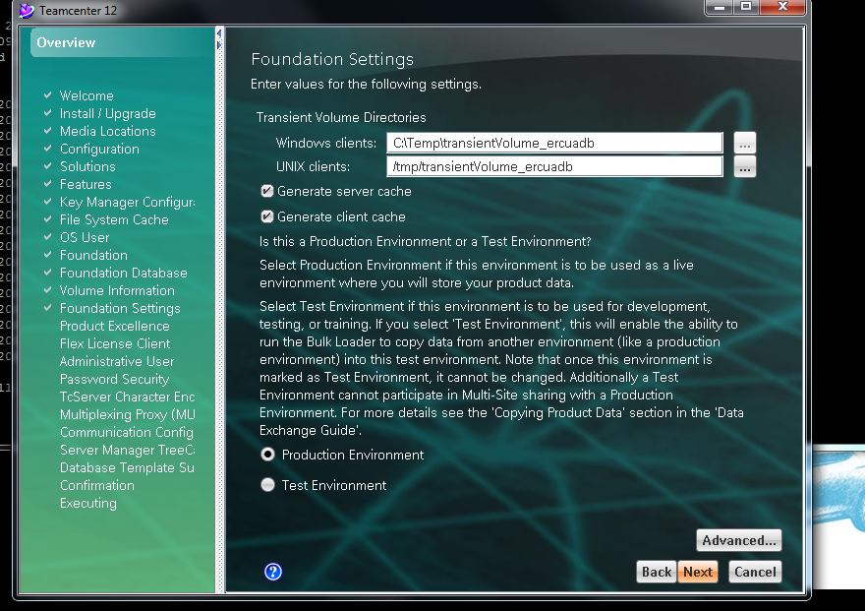

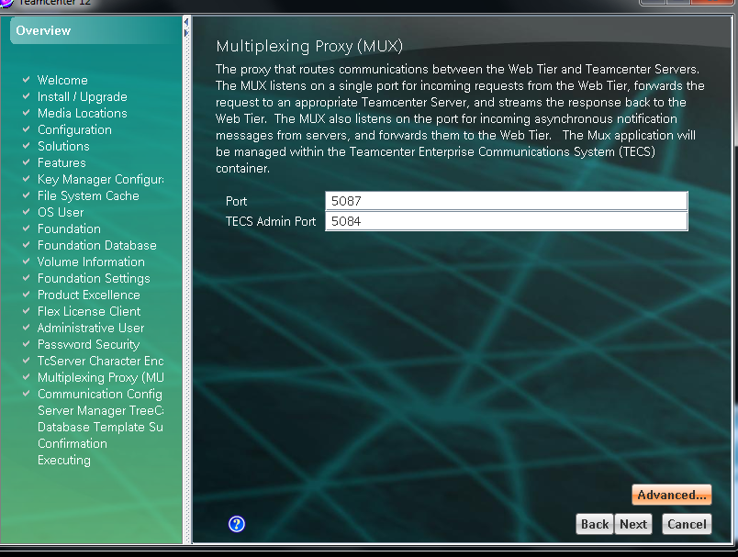

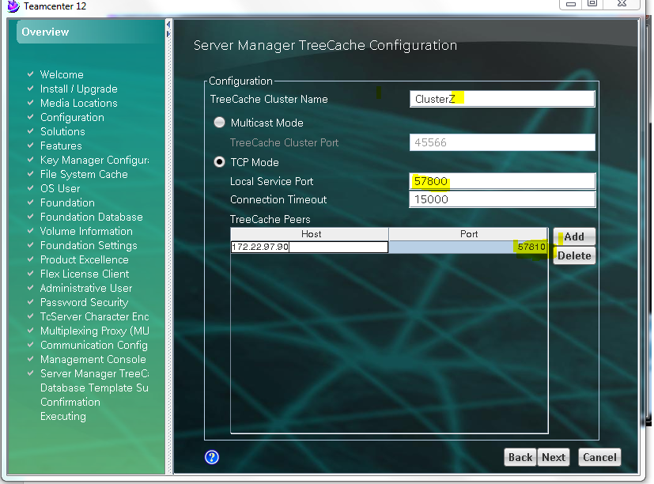

THEN NEXT – NEXT and start

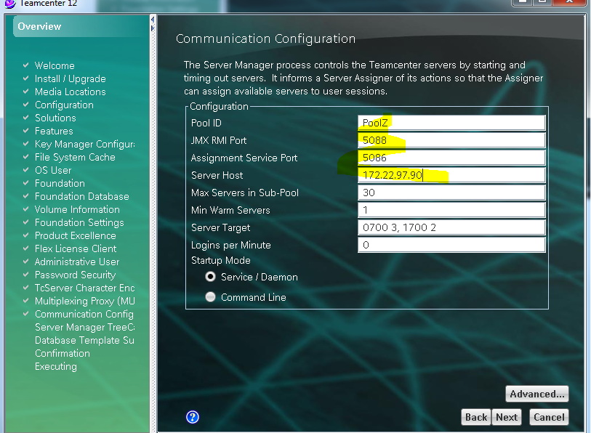

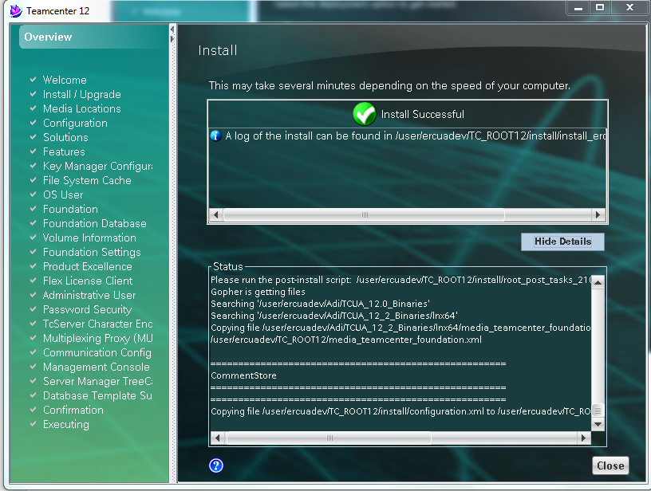 BASIC INSTALLATION COMPLETE

Mkdir WEB_ROOT on /user/ercuadev/TC_ROOT12

/user/ercuadev/TC_ROOT12/WEB_ROOT

THEN go to tc 12_2 binaries/lnx64
Then cd Web_Tier

/user/ercuadev/Adi/TCUA_12_2_Binaries/lnx64/Web_tier
Then from web_Tier folder cd /user/ercuadev/TC_ROOT12/WEB_ROOT

cat /user/ercuadev/Adi/TCUA_12_2_Binaries/lnx64/Web_tier/INSTALL_TCWEB.TZ | uncompress -c | tar xvf - this uncompresses the tar file
All these files are required for web client
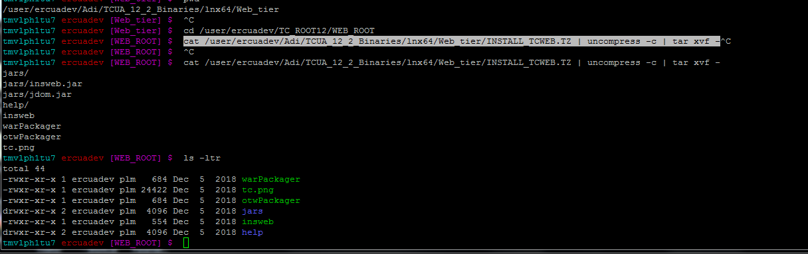
Then export DISPLAY=172.22.114.214:0.0

./insweb
Got an Error – before and after

Solution is shown below

tmvlph1tu7 ercuadev [WEB_ROOT] $ cat insweb
#!/bin/csh -f

# Wrapper to start up Teamcenter Enterprise Web Application Manager
# on UNIX using JRE 1.2

# bcprt
# This software and related documentation are proprietary to UGS Corp.
# COPYRIGHT 2006 UGS CORP. ALL RIGHTS RESERVED
# ecprt

# Set environment variables to enable help button
setenv EVISTA_HELPBASE file://`pwd`
setenv HELP_RELATIVE_DIR help
export JAVA_HOME=/usr/java/jdk1.8.0_201
if ( -r warPackager ) then
java -mx80m -cp "jars/insweb.jar:jars/jdom.jar" com.teamcenter.install.insweb.gui.Insweb
else
echo "You must be in the WEB_ROOT directory to run insweb."
endif

AFTER
tmvlph1tu7 ercuadev [WEB_ROOT] $ cat insweb
#!/bin/csh -f

# Wrapper to start up Teamcenter Enterprise Web Application Manager
# on UNIX using JRE 1.2

# bcprt
# This software and related documentation are proprietary to UGS Corp.
# COPYRIGHT 2006 UGS CORP. ALL RIGHTS RESERVED
# ecprt

# Set environment variables to enable help button
setenv EVISTA_HELPBASE file://`pwd`
setenv HELP_RELATIVE_DIR help

if ( -r warPackager ) then
/usr/java/jdk1.8.0_201/bin/java -mx80m -cp "jars/insweb.jar:jars/jdom.jar" com.teamcenter.install.insweb.gui.Insweb
else
echo "You must be in the WEB_ROOT directory to run insweb."
Endif

Run INSWEB-------- ./insweb
Copy icd – browse – go to below path
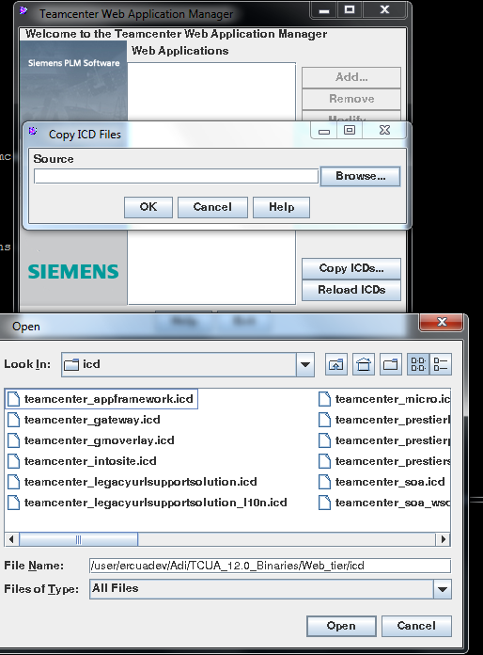

Do the same for 12.2

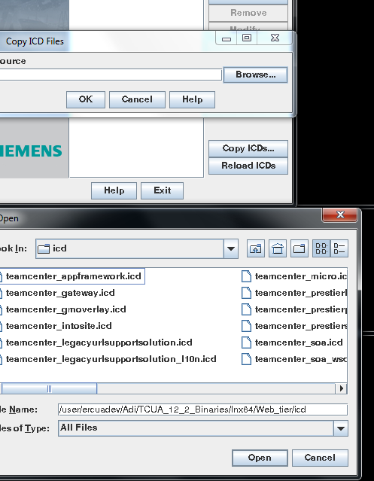

Click on add AND THEN ADD ALL CHANGES HIGHLIGHTED BELOW

In advanced web application options check distributable and deployment file name
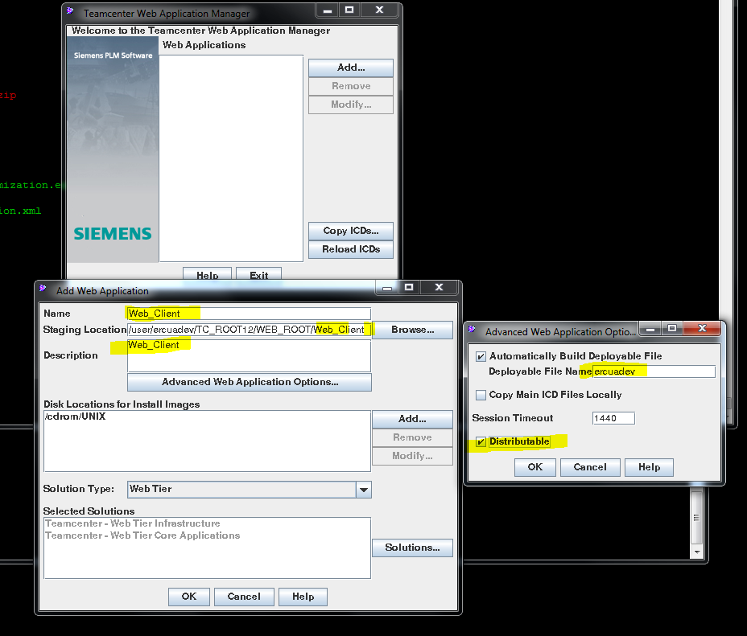

Remove cdrom/unix and the click on add
Give path of 12.0 web tier

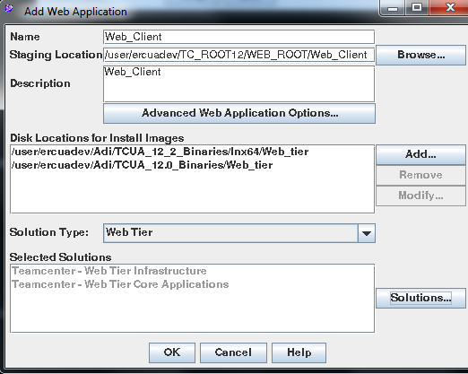

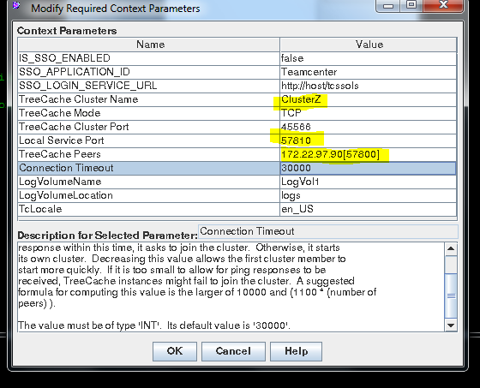
THIS GENERATES THE WAR FILE

Now to install web logic

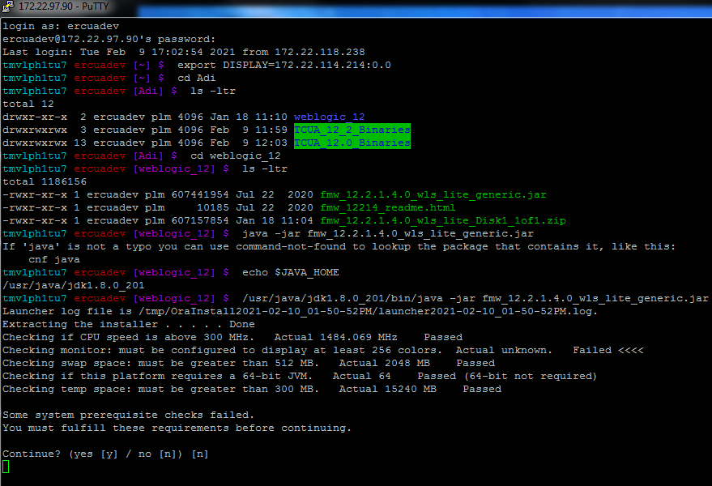

Web ogic installation

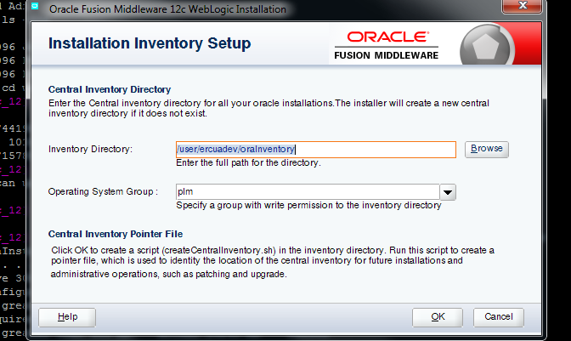

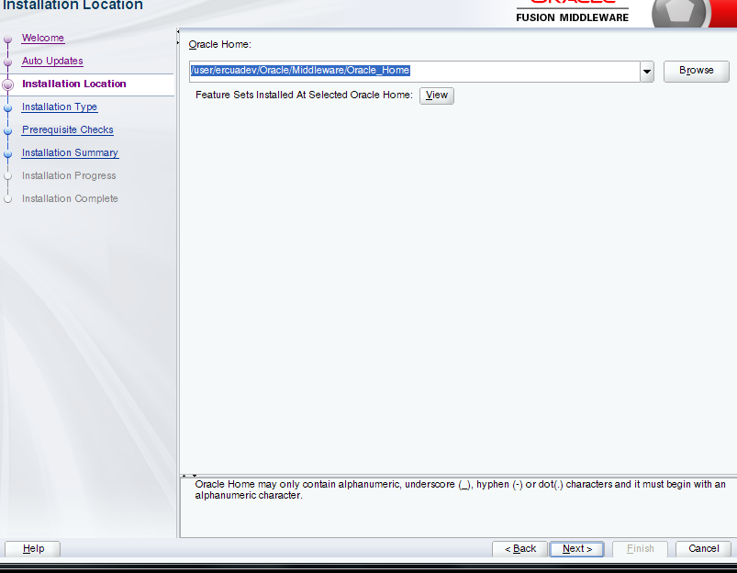

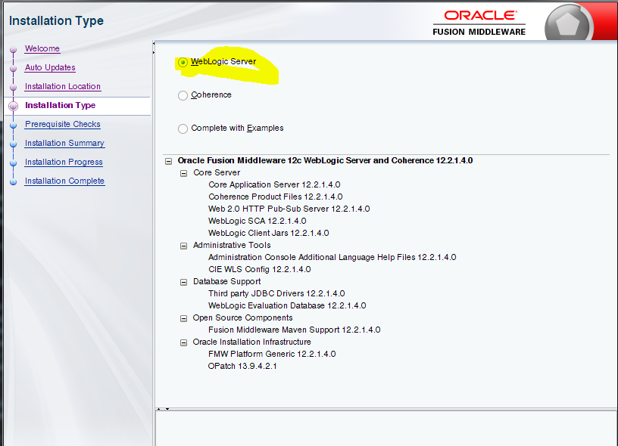

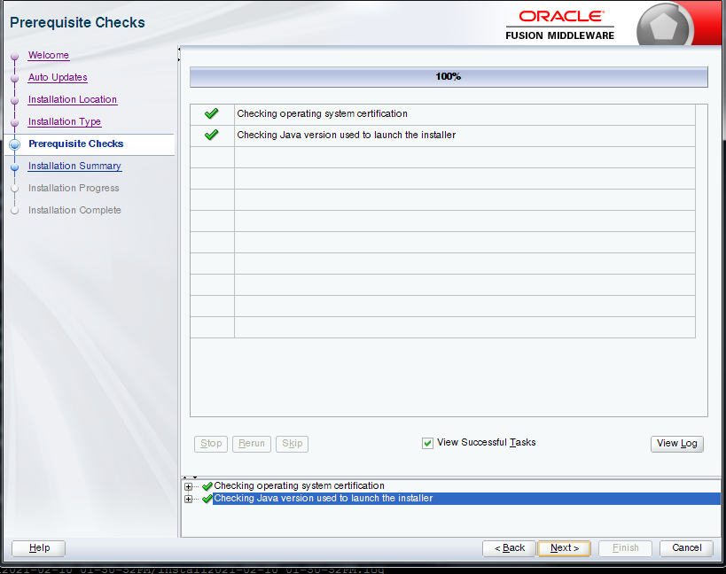

Then next- click on install

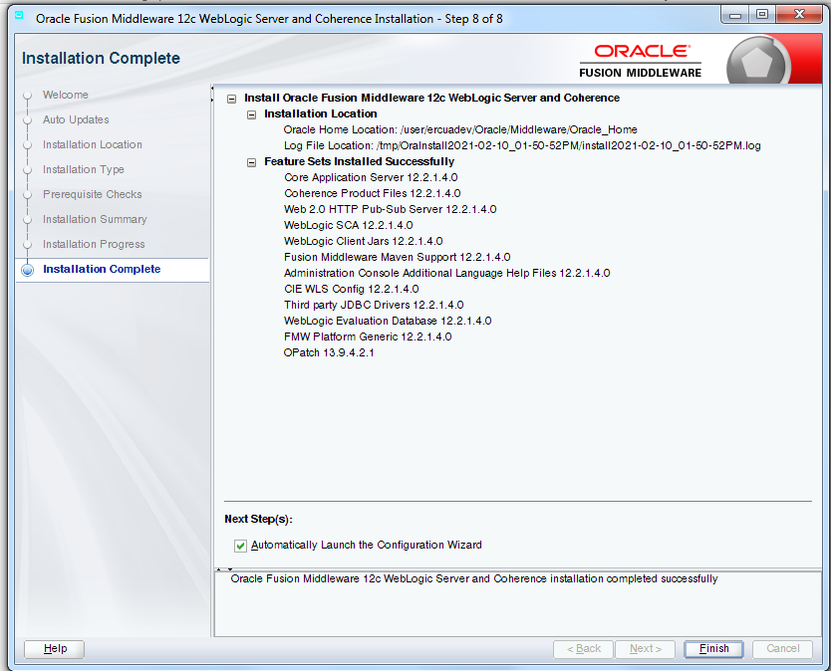

This installs the server --- now to move on to domains

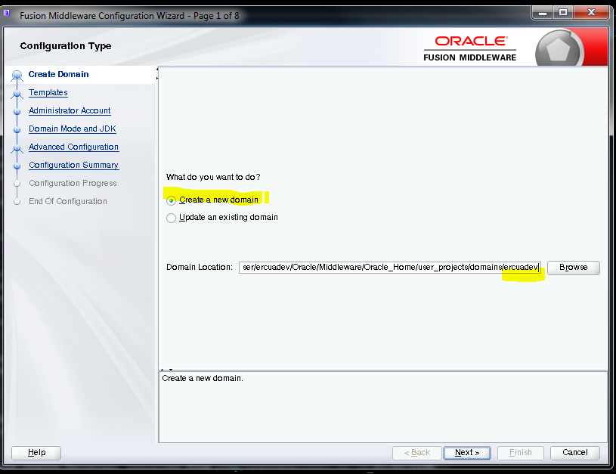

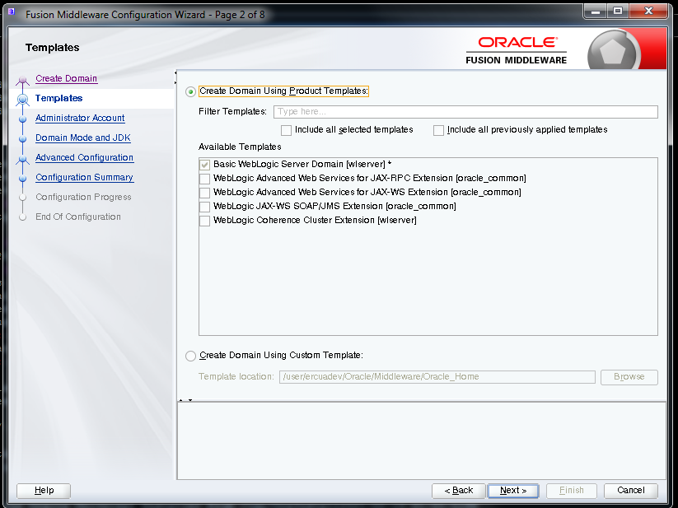

Weblogic – weblogic1 password

/user/ercuadev/Oracle/Middleware/Oracle_Home/wlserver/common/bin

./config.sh
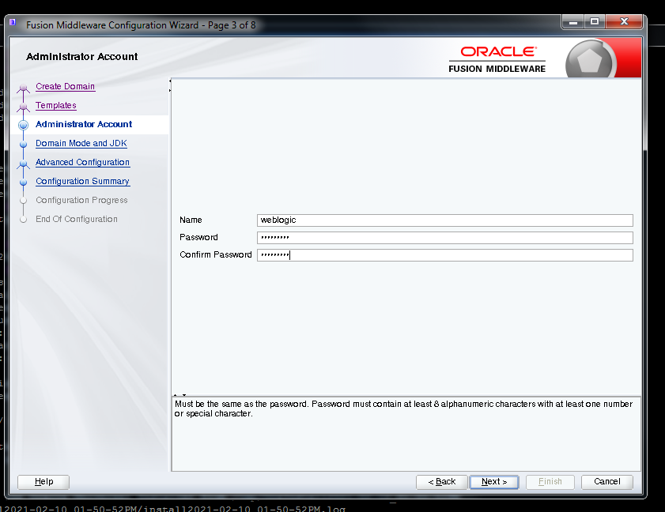

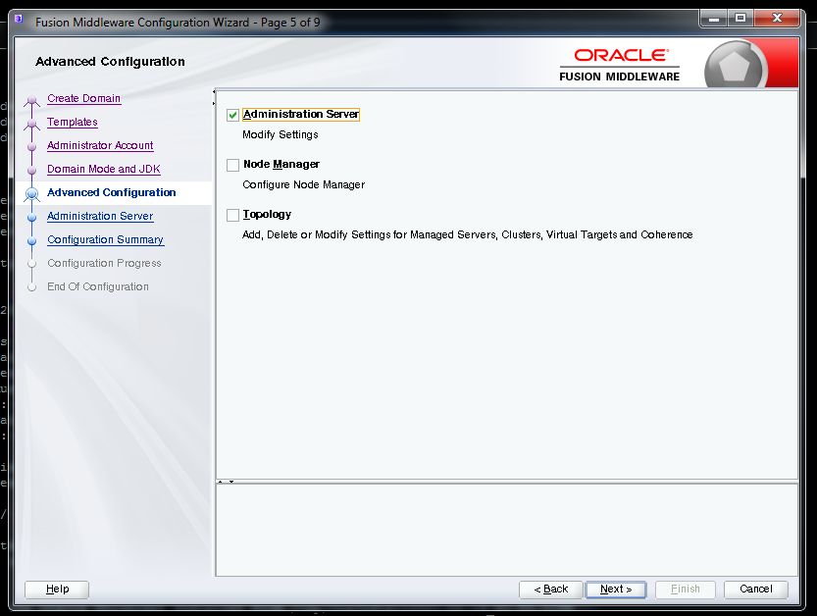

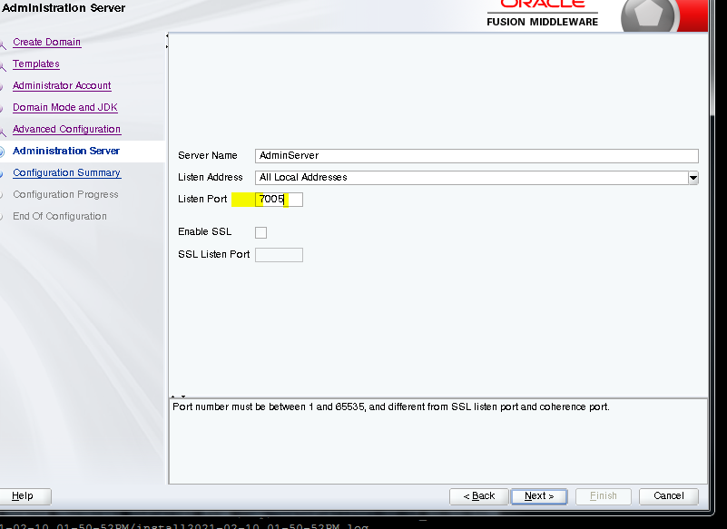
7007

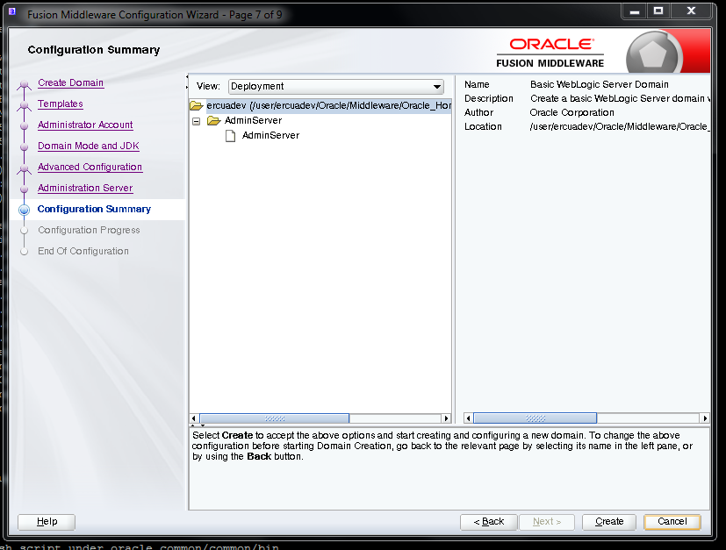

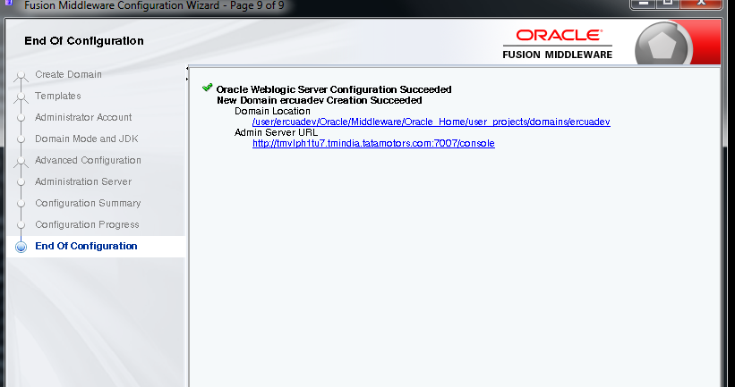

/user/ercuadev/Oracle/Middleware/Oracle_Home/user_projects/domains/ercuadev/bin

nohup ./startWebLogic.sh &

http:/172.22.97.90:7007/console – from Mozilla

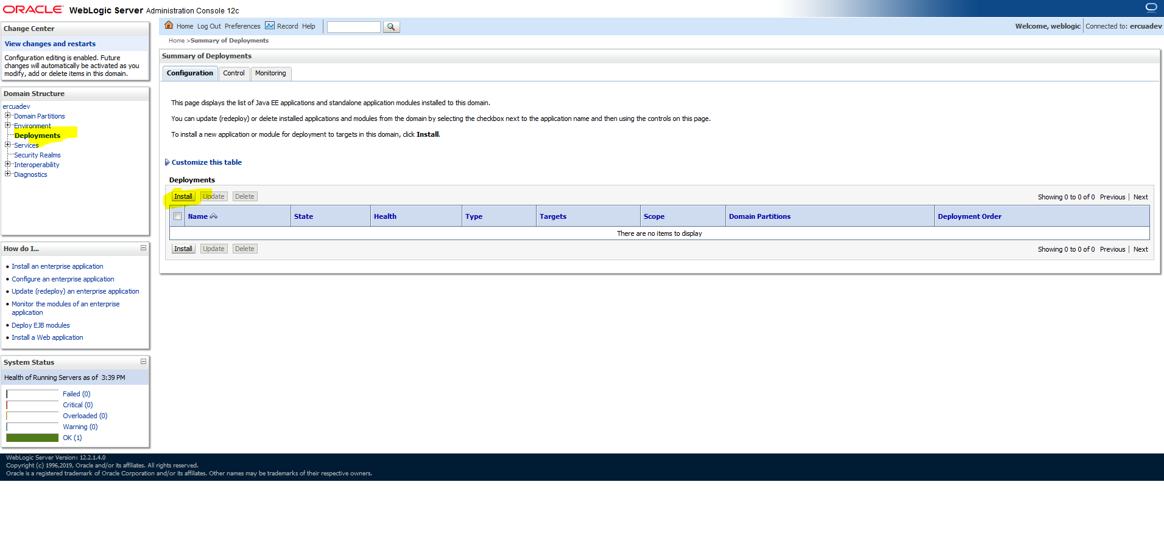

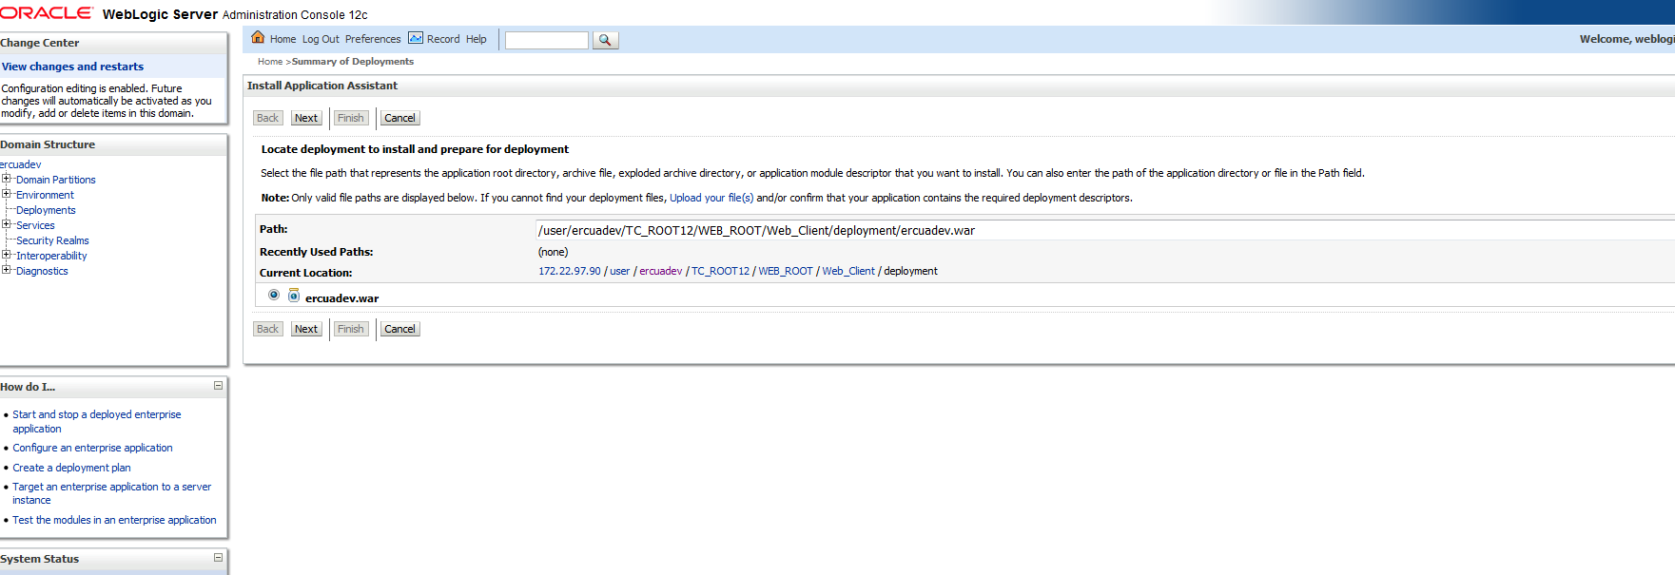

Next – next – nex t- fininsh

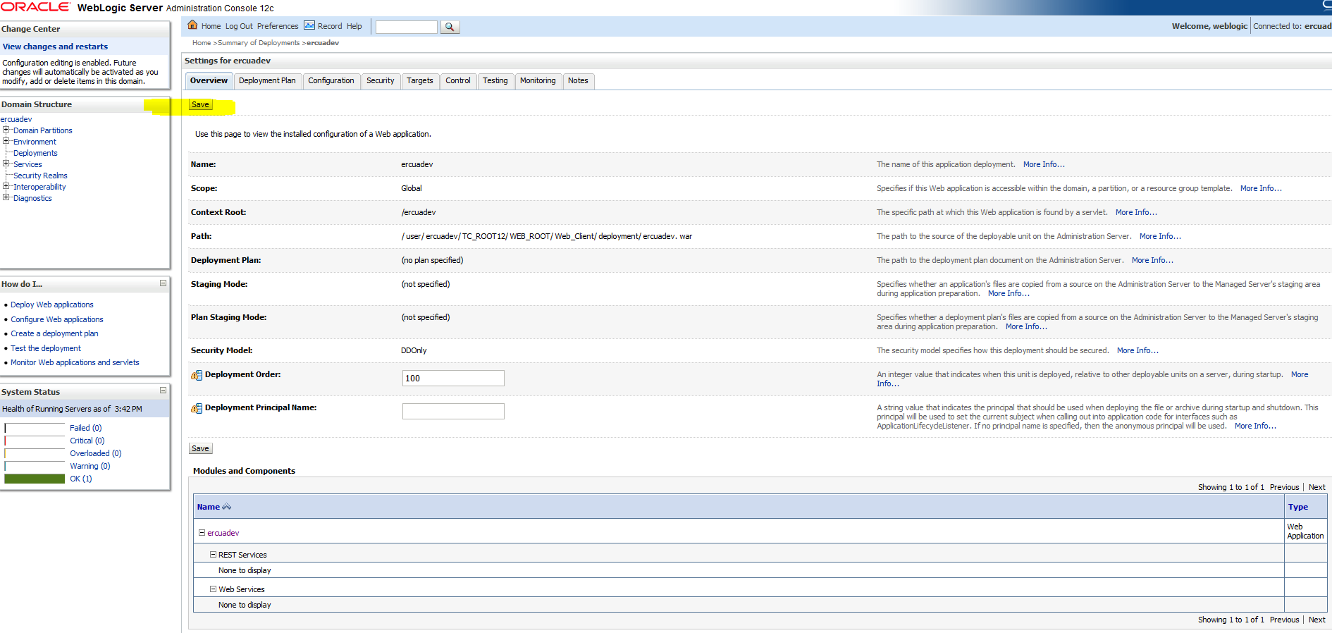

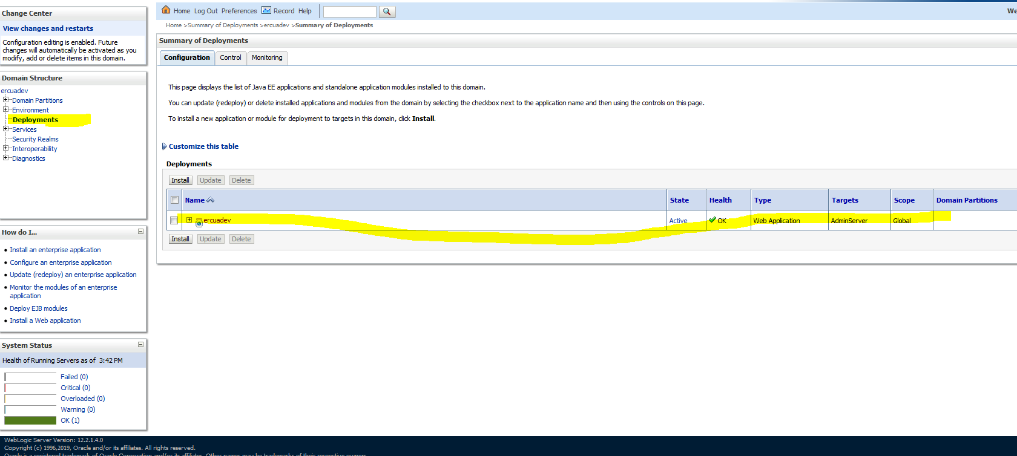

Then restart services
3 services – fsc – pool manager & web logic

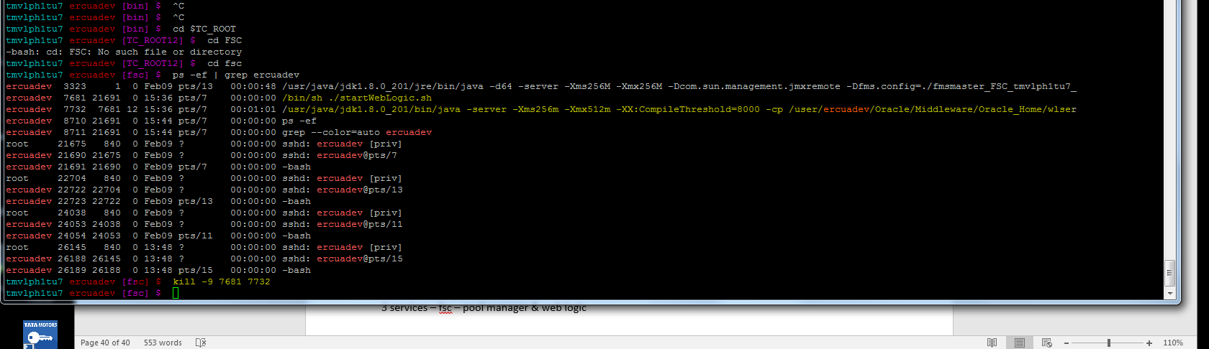

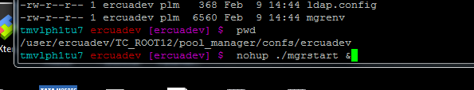

Web logic services start
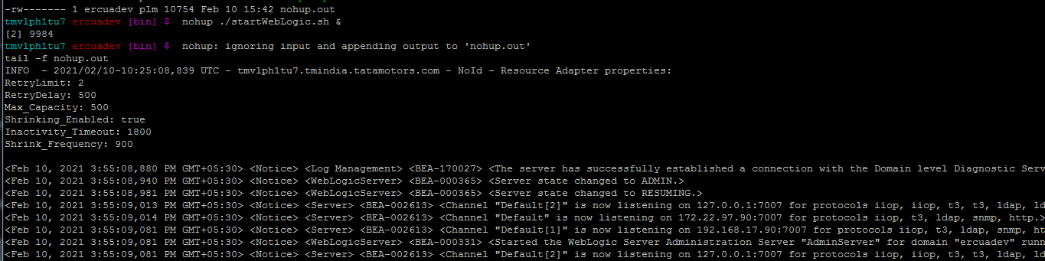

To install client on server --- run tem from binaries

To install cmir2 template or product configurator etc

/user/ercuadev/Adi/TCUA12UpgradedTemplates/CMIR2/CMIRII_Server_TC12.0_V430/CMIRII_Server_Template_TC12.0_V430/tem_contributions

